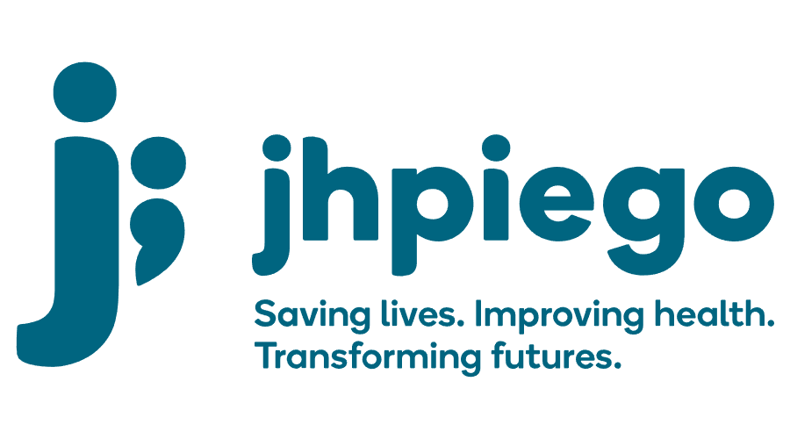

Jhpiego is an international, non-profit health organization affiliated with [The Johns Hopkins University](http://www.jhu.edu/). For 40 years and in over 155 countries, Jhpiego has worked to prevent the needless deaths of women and their families.

Jhpiego Corporation has been providing technical support to the Ministries of Health in partner countries across the globe for the past 40 years in a variety of technical areas including cervical cancer treatment and prevention, community health, HIV and AIDS, maternal and newborn health, health workforce capacity development (both pre-service and in-service), family planning, malaria, and IPC/WASH.

The Global Reach II project is a five-year global HRSA-funded project, which started in October, 2021. It employs an iterative approach based on a country’s needs, informed by clients and beneficiaries, targeting high-priority populations and low-coverage and poor-performing areas to achieve HIV epidemic control. In Sierra Leone, Global Reach II works with government and builds local capacity to identify and implement proven solutions where they exist and develop innovative solutions to overcome persistent barriers that affect HIV services. Global Reach II will develop the capacity of the interdisciplinary health workforce to provide quality, client-centered care, ensuring that individuals will be informed and empowered to access services, receive high-quality care, adhere to treatment and remain in care, ultimately contributing to achievement of HIV epidemic control in Sierra Leone.

The following vacant position is available for immediate filling:

**Procurement Officer (1 position)**

**Job Location:  Freetown**

**Reports to:  Senior Finance and Operations Manager**

**Supervises: N/A**

**Position Overview:**

The Procurement Specialist supports the Operations Team in undertaking all procurement requirements of the Country Office. This includes sourcing, completing Basis for Vendor Selection (BVS), raising of Purchase Orders (POs)/contracts, negotiating, purchasing and liaising with all vendors/suppliers and ensure implementation of Procurement processes and procedures according to Jhpiego Procurement Manual.

**Duties and Responsibilities:**

* Support the development of a consolidated procurement plan for all Jhpiego Sierra Leone projects and its implementation.
* Establish a preferred vendors database for the Freetown office and additional in-country sites
* Perform procurement functions including; soliciting for quotations, negotiating prices, after sale services with vendors, raising purchase orders/contracts, verifying business registration and tax clearance certificates of vendors/suppliers for validity.
* Generate Basis for Vendor Selection (BVS) and ensure that they are fully approved.
* Ensure that completed purchase orders are forwarded to Finance Team for goods receipt and payment purposes and Administrative and Logistics Officer for inventory management purposes.
* Ensure that invoices for vendors are submitted to Finance Team for timely payment.
* Assist in the clearance of shipments from customs or any other government body in collaboration with appropriate staff.
* Work with Logistics Officer to ensure that documentation related to donation/hand over of supplies or equipment to facilities supported by Jhpiego is properly kept.
* Work with Logistics Officer and Sr. Finance and Operations Manager to ensure all office equipment is captured in the inventory as soon as such have been delivered to Jhpiego Sierra Leone.
* Provide support to the annual inventory counts as appropriate.
* Maintain and update procurement records and ensure that copies are properly filed.
* Implement the procurements policies/procedures as outlined in Jhpiego Procurement Manual.
* Assist in coordinating with Jhpiego Baltimore staff on approvals of POs/Contracts that require HQ approvals, shipments, clearing and deliveries to the office.
* Monitor open POs and advice on their status
* Do monthly reports on open POs
* Any other duty that may be assigned from time to time.

# **Required Qualifications, Experience and Skills:**

* Minimum qualification of first Degree in Procurement or Business Administration
* Minimum 5 years of relevant experience in procurement and logistics.
* Experience working in a procurement unit of an international NGO or related organization with procurement tasks for a minimum of 5 years.
* Experience in procurement and stock and inventory management
* Computer skills including demonstrated hands-on-experience in MS Word, MS PowerPoint, and MS Excel.
* Experience in database management
* An understanding of relevant legislation in relation to USG regulations, policies and procedures as they relate to procurement
* Experience working in a multicultural organization
* Self-motivated, proactive and have a positive attitude to work requiring minimum supervision.
* High attention to detail
* Hardworking, flexible & dependable.
* Ability to communicate effectively, instilling trust and confidence.
* Excellent interpersonal and communication skills.
* Be of high integrity and have a sense of confidentiality
* Be willing to take on extra responsibilities, sometimes working overtime, in order to achieve the goals/objectives set by the organization

**Qualified persons are required to send their Curriculum Vitae (CV) and application letter to:**  [GH-Recruitments@jhpiego.org](mailto:GH-Recruitments@jhpiego.org)

**Deadline for the submission of applications: November 19, 2021. Please note that given the likely high volume of applications, only shortlisted candidates will be contacted.**